**Starting Definitions**

**Cell**: the smallest structural unit of living matter capable of functioning independently

**Microbe**: an organism, such as a bacterium, of microscopic size

**Organelle:** An organ-like structure inside a cell that helps the conduct different functions

**Activity Overview**

Just like how we have a heart and lungs, microbes have organ structures inside them called organelles. Organelles are important for cells because they help the cell survive and thrive in different environments. For example, plasmids (which are featured in this activity), allow microbes to glow in the dark, or be resistant to antibiotics! There is a great diversity of structures in microbes, and these functional and structural differences help a cell survive and thrive in environments around the world and beyond.

In this activity, you will get to build your very own cell, and decide what organelles it will have to help it survive and thrive in an environment of your choosing. Keep in mind, you don’t have to use every piece that was sent. For example, if you don’t want to have a microbe that contains gas vacuoles because you don’t think it would be useful for the environment that you imagine your microbe living in, don’t add them.

**Your Cell:**

This is called a petri dish. In this activity, it represents your microbial cell. In science, petri dishes are often filled with a microbe food substance called agar, and used to grow microbes!

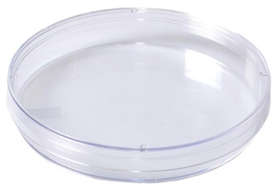

**Organelles/cellular structures you can add**:

Magnetosomes

Magnetosomes are iron crystals wrapped in a membrane, and function similar to a compass needle. They align bacteria to magnetic fields, helping them find their preferred living environments.

Endospores

An endospore is a dormant structure produced by some microbes. It is essentially a hibernating, simplified form to which a bacterium can reduce itself in times of high stress (i.e. lack of nutrients).

Carbon storage

Carbon is frequently utilized to both build and power microbes. As such, some microbes have developed specific pathways, proteins, or structures that allow them to store carbon for later use. This process can be less of a physical structure, and more of a regulatory pathway.

Energy Storage

In a very similar vein as the Carbon Storage above, microbes have developed other means of storing the substances they use for energy. Having the ability to store energy helps microbes survive for short periods of time where food sources might be scarce.

Plasmids

A plasmid is a circular strand of “accessory” DNA that isn’t required for basic functioning. Plasmids often confer extra, useful functions to the bacteria that they are present in, such as causing the cells to glow in the dark, conferring antibiotic resistance, and more.

Gas Vacuole

Gas vacuoles are structures inside cells that can inflate/deflate with gas, allowing microbes to adjust their buoyancy to float or sink. This means that they can move around in water better than cells that don’t have one.

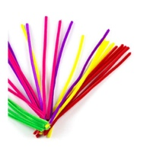Flagella

Flagella help a cell move. You glue flagella on the outside of your cell, instead of the inside.

**Assembly:**

Now that you have learned about all of the organelles that you could put in your cell, pick which organelles you would like to include. Think about how these organelles will help your cell survive. Arrange them how you like them, and apply glue to both the petri dish and the organelle. Let the glue dry completely before hanging it in your window. Afterwards, answer the questions below about your microbe!

This is an example of what your cell can look like!

**Questions:**

* Describe the type of environment that your microbe could live in. Since microbes exist in even extreme environments (deep sea vents, space, Yellowstone Hot Springs), be specific.
* There are many different types of organelles out there, way more than are included in this activity. If you could make up an organelle to give to your microbe, what would it do? Why would it help your microbe?